**Question 1**

-- 1

**create database Dept;**

**use Dept;**

**create table Department(**

**Dept_no int,**

**Dept_Name varchar(20),**

**Location varchar(20),**

**primary key(Dept_no)**

**);**

**create table Employee(**

**Emp_no int,**

**Emp_Name varchar(20),**

**Salary int,**

**Dept_no int,**

**primary key(Emp_no),**

**foreign key(Dept_no) references Department(Dept_no) ON delete cascade**

**);**

-- 2

insert into Department values

(101,"HR","TVM"),

(102,"Analytics","Kochi"),

(103,"Development","Bangalore"),

(104,"Research","Hyderabad");

insert into Employee values

(1,"Vimal",45000,101),

(2,"Arya",50000,102),

(3,"Tom",65000,103),

(4,"Ann",75000,104),

(5,"Sharath",40000,101),

(6,"Ahmed",55000,103),

(7,"Riya",65000,104);

-- 3

**select sum(Salary) from Employee;**

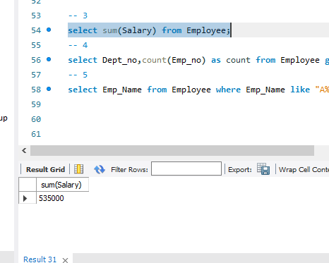

-- 4

**select d.Dept_Name,count(Emp_Name) as count from Employee e,Department d where d.Dept_no=e.Dept_no group by d.Dept_no;**

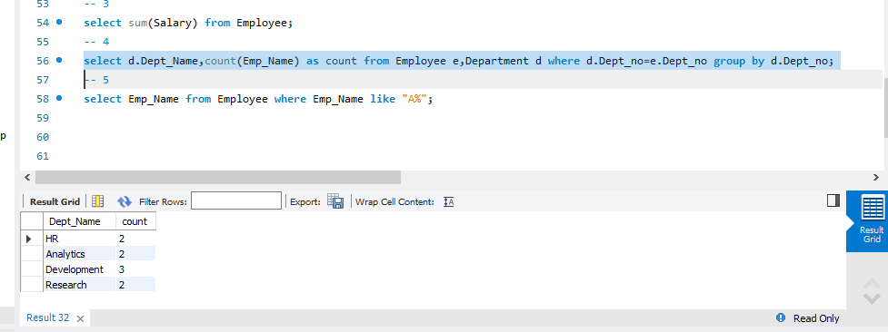

-- 5

**select Emp_Name from Employee where Emp_Name like "A%";**

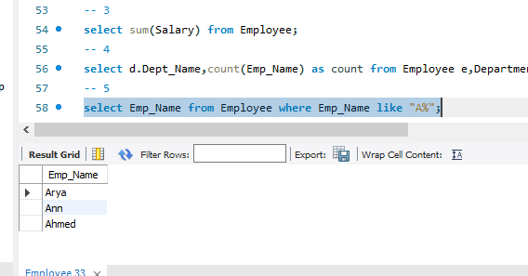

**Question 2**

> use exam

switched to db exam

> db.createCollection("student")

{ "ok" : 1 }

db.student.insertMany([{_id:1,Name:"Anjali",Place:"Kollam",Phone:"8582639562",Vac_Stat:"Both",RTPCR:"negative",lab:{int:30,ext:45},Dept:"MCA"},{_id:2,Name:"Anuradha",Place:"Varkala",Phone:"9992639562",Vac_Stat:"Both",RTPCR:"negative",lab:{int:40,ext:48},Dept:"Civil"}])

db.student.insertMany([{_id:3,Name:"Bismiya",Place:"Kollam",Phone:"9446639562",Vac_Stat:"Not",RTPCR:"positive",lab:{int:50,ext:39},Dept:"MCA"},{_id:4,Name:"Vimal",Place:"Ernakulam",Phone:"8582639568",Vac_Stat:"First",RTPCR:"positive",lab:{int:40,ext:42},Dept:"Civil"},{_id:5,Name:"Vivek",Place:"Kollam",Phone:"8582639777",Vac_Stat:"Both",RTPCR:"negative",lab:{int:50,ext:50},Dept:"MCA"}])

{ "acknowledged" : true, "insertedIds" : [ 3, 4, 5 ] }

> db.student.find().pretty()

{

"_id" : 1,

"Name" : "Anjali",

"Place" : "Kollam",

"Phone" : "8582639562",

"Vac_Stat" : "Both",

"RTPCR" : "negative",

"lab" : {

"int" : 30,

"ext" : 45

},

"Dept" : "MCA"

}

{

"_id" : 2,

"Name" : "Anuradha",

"Place" : "Varkala",

"Phone" : "9992639562",

"Vac_Stat" : "Both",

"RTPCR" : "negative",

"lab" : {

"int" : 40,

"ext" : 48

},

"Dept" : "Civil"

}

{

"_id" : 3,

"Name" : "Bismiya",

"Place" : "Kollam",

"Phone" : "9446639562",

"Vac_Stat" : "Not",

"RTPCR" : "positive",

"lab" : {

"int" : 50,

"ext" : 39

},

"Dept" : "MCA"

}

{

"_id" : 4,

"Name" : "Vimal",

"Place" : "Ernakulam",

"Phone" : "8582639568",

"Vac_Stat" : "First",

"RTPCR" : "positive",

"lab" : {

"int" : 40,

"ext" : 42

},

"Dept" : "Civil"

}

{

"_id" : 5,

"Name" : "Vivek",

"Place" : "Kollam",

"Phone" : "8582639777",

"Vac_Stat" : "Both",­­­­­

"RTPCR" : "negative",

"lab" : {

"int" : 50,

"ext" : 50

},

"Dept" : "MCA"

**Qn3)**

**> db.student.count({Vac_Stat:"Not"})**

**1**

**C:\Users\Admin\AppData\Local\Microsoft\Windows\INetCache\Content.Word\qn2.3.png**

**Qn 4)**

**> db.student.find({Dept:"MCA"},{Name:1,Phone:1}).sort({'lab.ext':-1})**

{ "_id" : 5, "Name" : "Vivek", "Phone" : "8582639777" }

{ "_id" : 1, "Name" : "Anjali", "Phone" : "8582639562" }

{ "_id" : 3, "Name" : "Bismiya", "Phone" : "9446639562" }

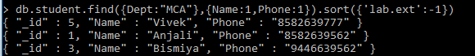

**Qn 5)**

**> db.student.updateOne({_id:4},{$set:{Vac_Stat:"Both"}})**

{ "acknowledged" : true, "matchedCount" : 1, "modifiedCount" : 1 }



> db.student.find({_id:4}).pretty()

{

"_id" : 4,

"Name" : "Vimal",

"Place" : "Ernakulam",

"Phone" : "8582639568",

"Vac_Stat" : "Both",­­­­­­­­

"RTPCR" : "positive",

"lab" : {

"int" : 40,

"ext" : 42

},

"Dept" : "Civil"

}